
Department of CSE

B.Tech. CSE Trimester -5

2520030591
T. Sudeshna

Cloud Infrastructure and Services
25CS2206E

LAB SKILL
2026

SKILL Experiments -1

1.Create an IAM user with programmatic access only, download the access key and secret key, and document the steps with screenshots. Then set up a billing alert for the account so that an email is received when the Free Tier limit is about to be crossed.
DESCRIPTION: This screenshot shows the AWS IAM user creation page where the username is entered and programmatic access is selected.
Steps:
- Log in to the AWS Management Console.
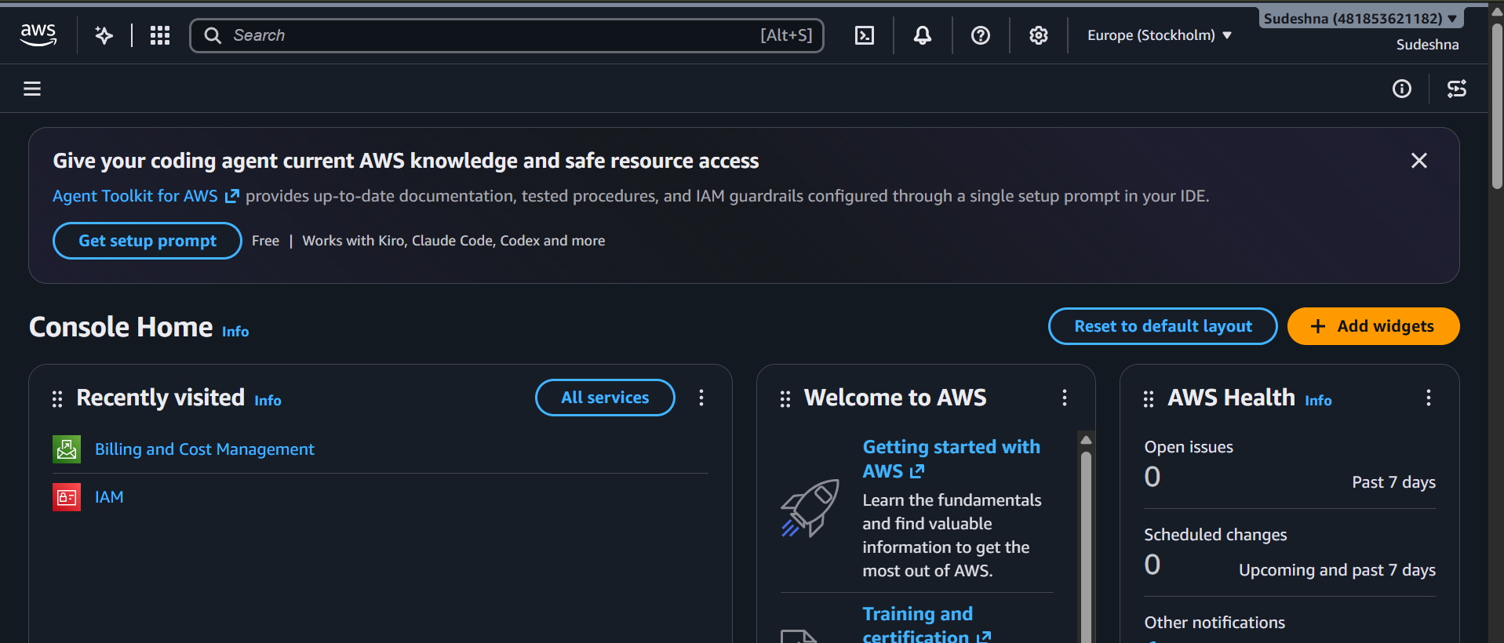
2.Search for IAM in the AWS services search bar. 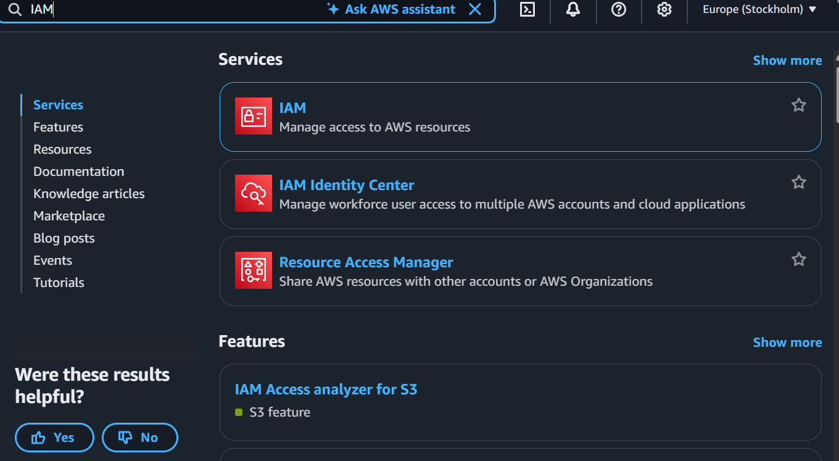

3. Navigate to IAM → Users.
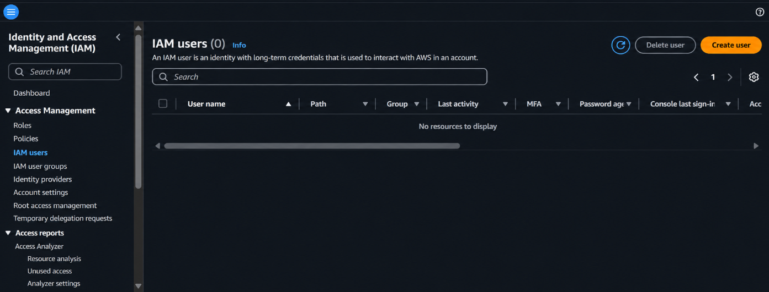

4. Enter the required username
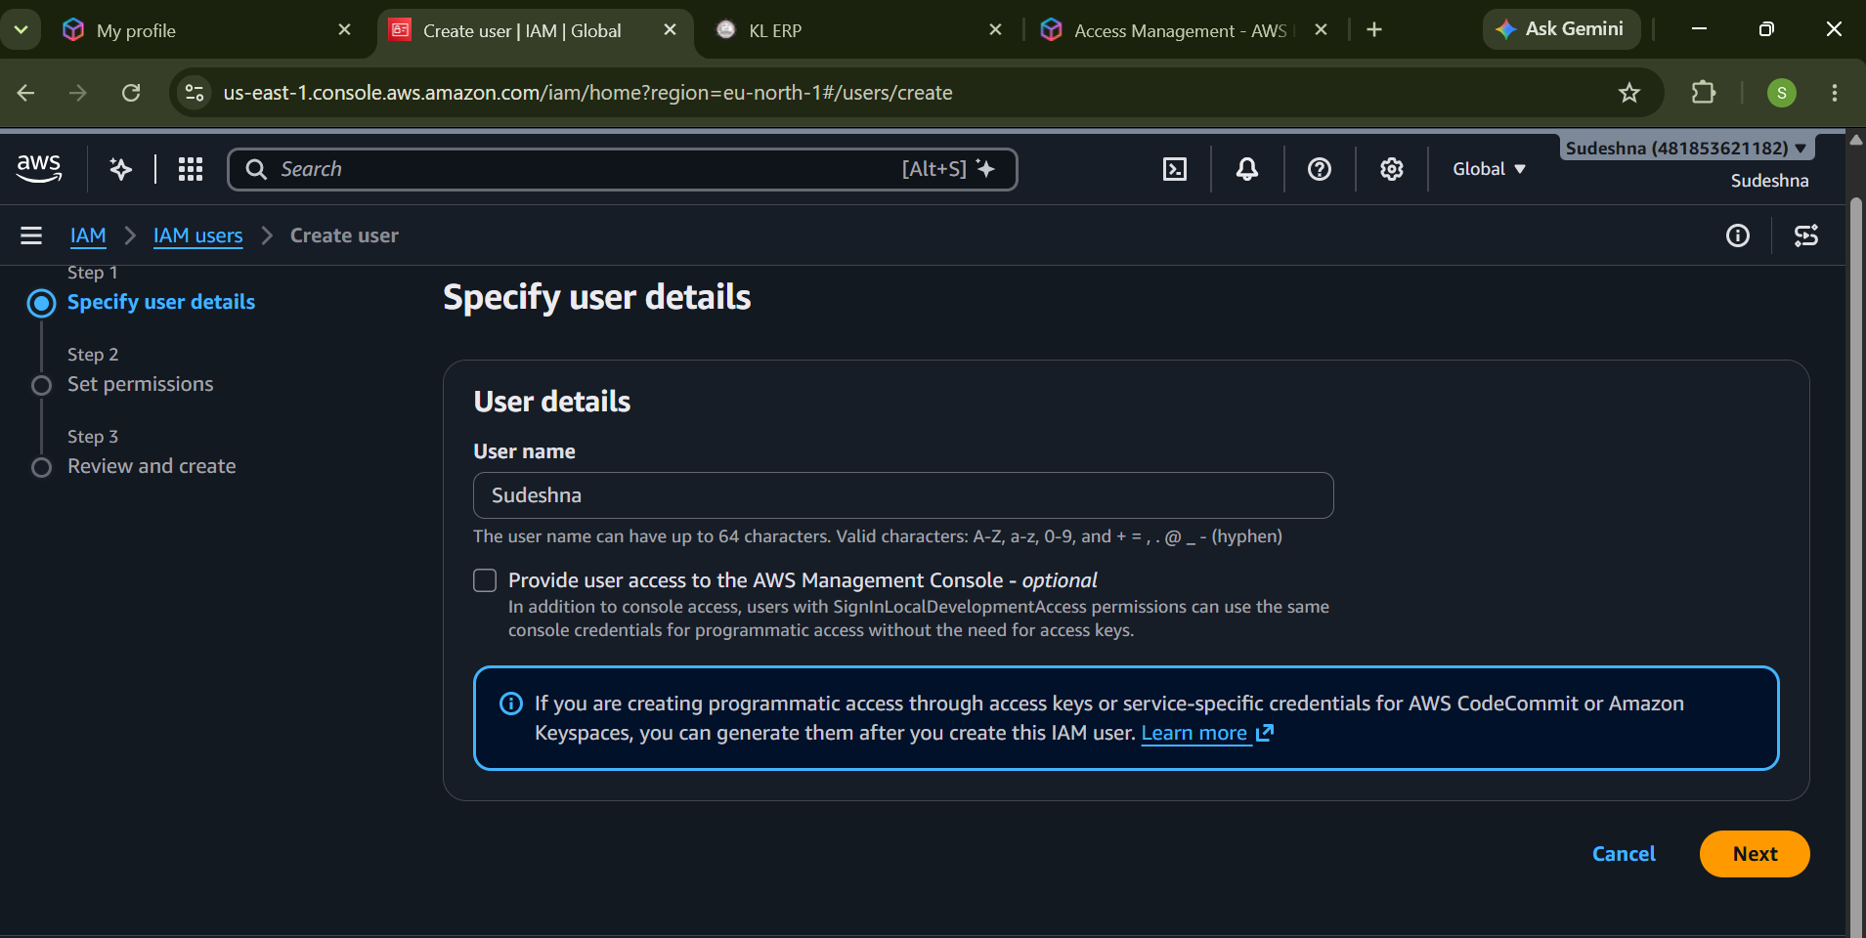
Description: This screenshot displays the IAM user configuration with programmatic access enabled.

5.Selecting Permission policies
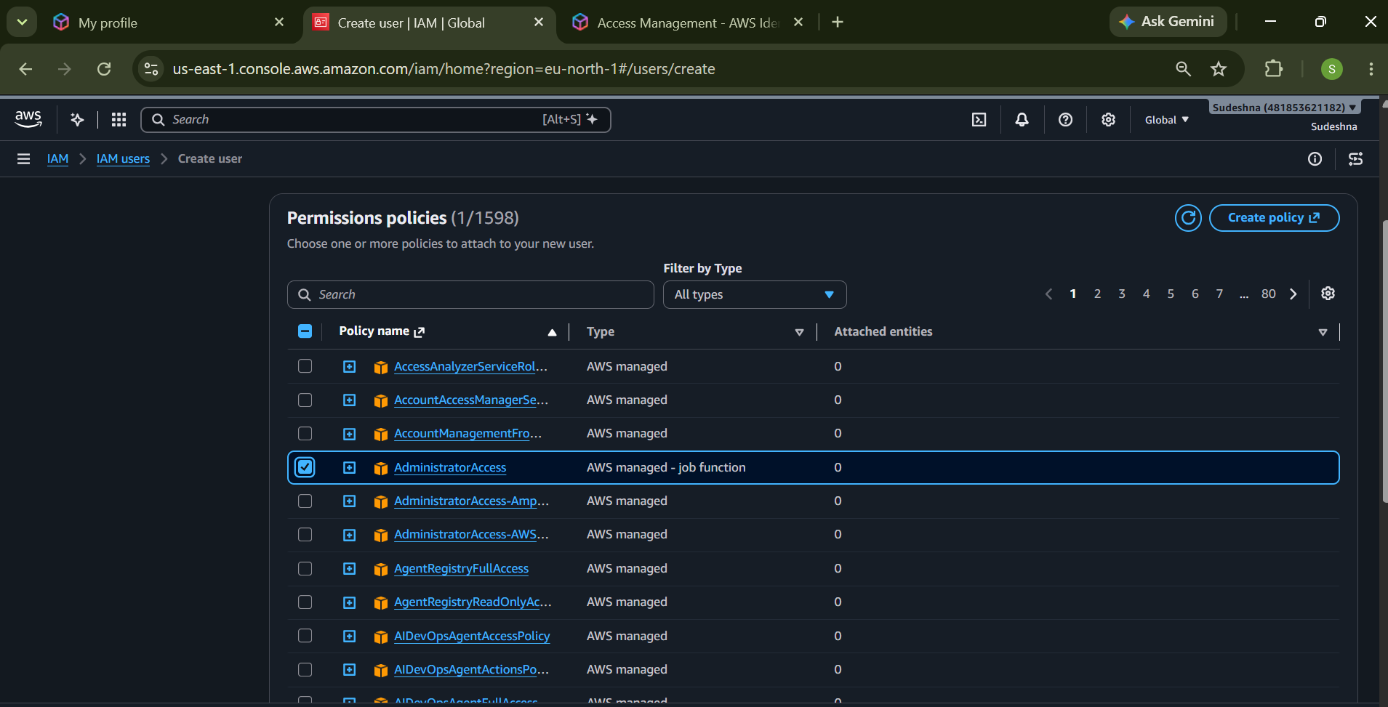
Description: This screenshot shows the permissions configuration page where permissions are assigned to the IAM user.

- click create user
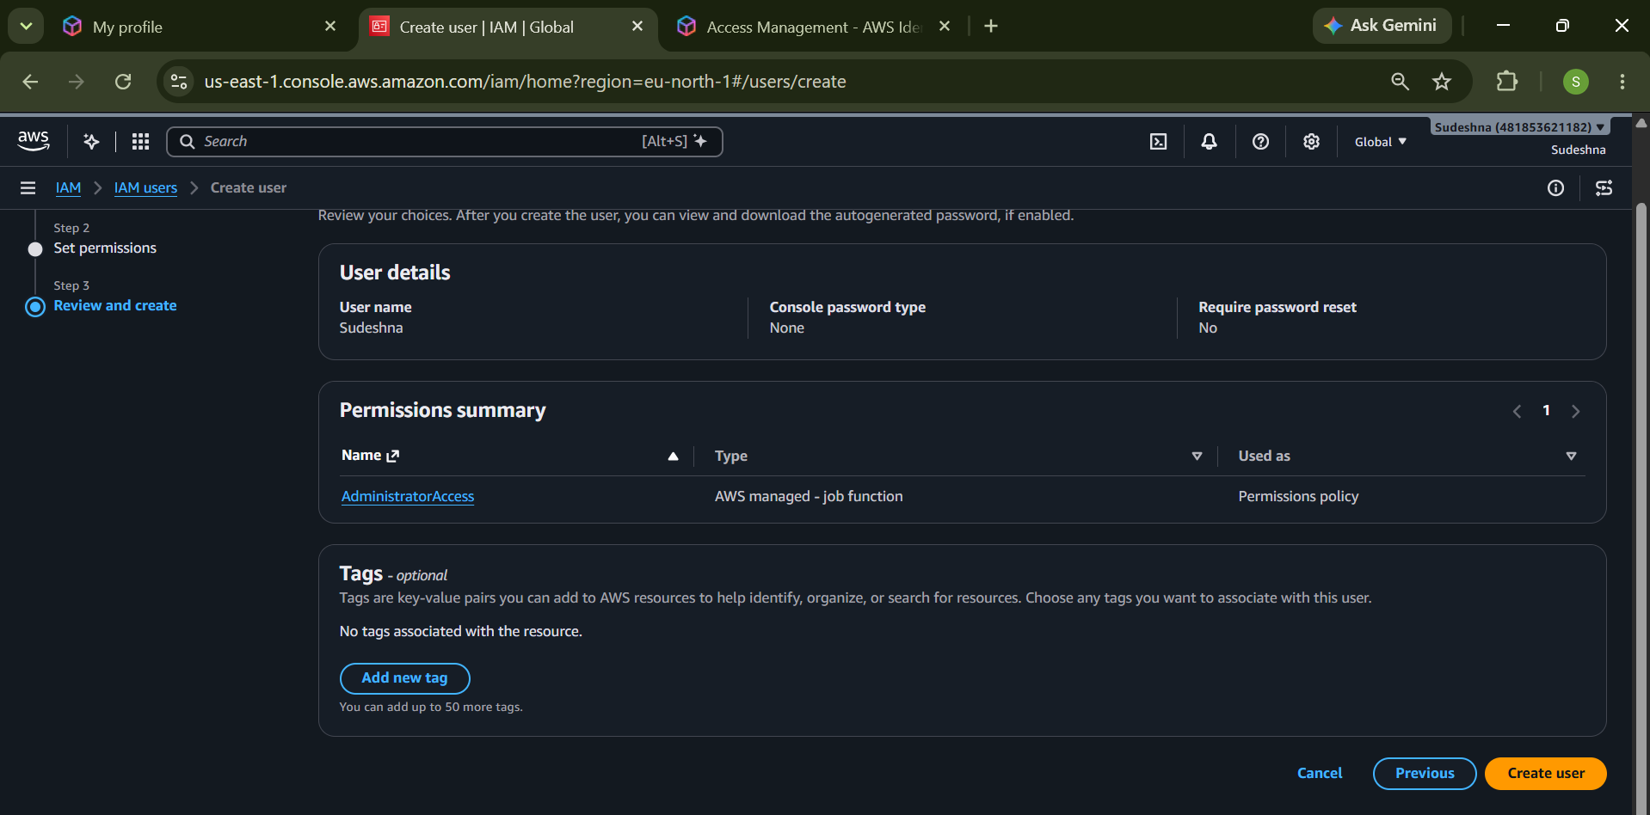
Description: This screenshot shows the review page containing the IAM username and permission details before creating the us.

7.User Creation Processing
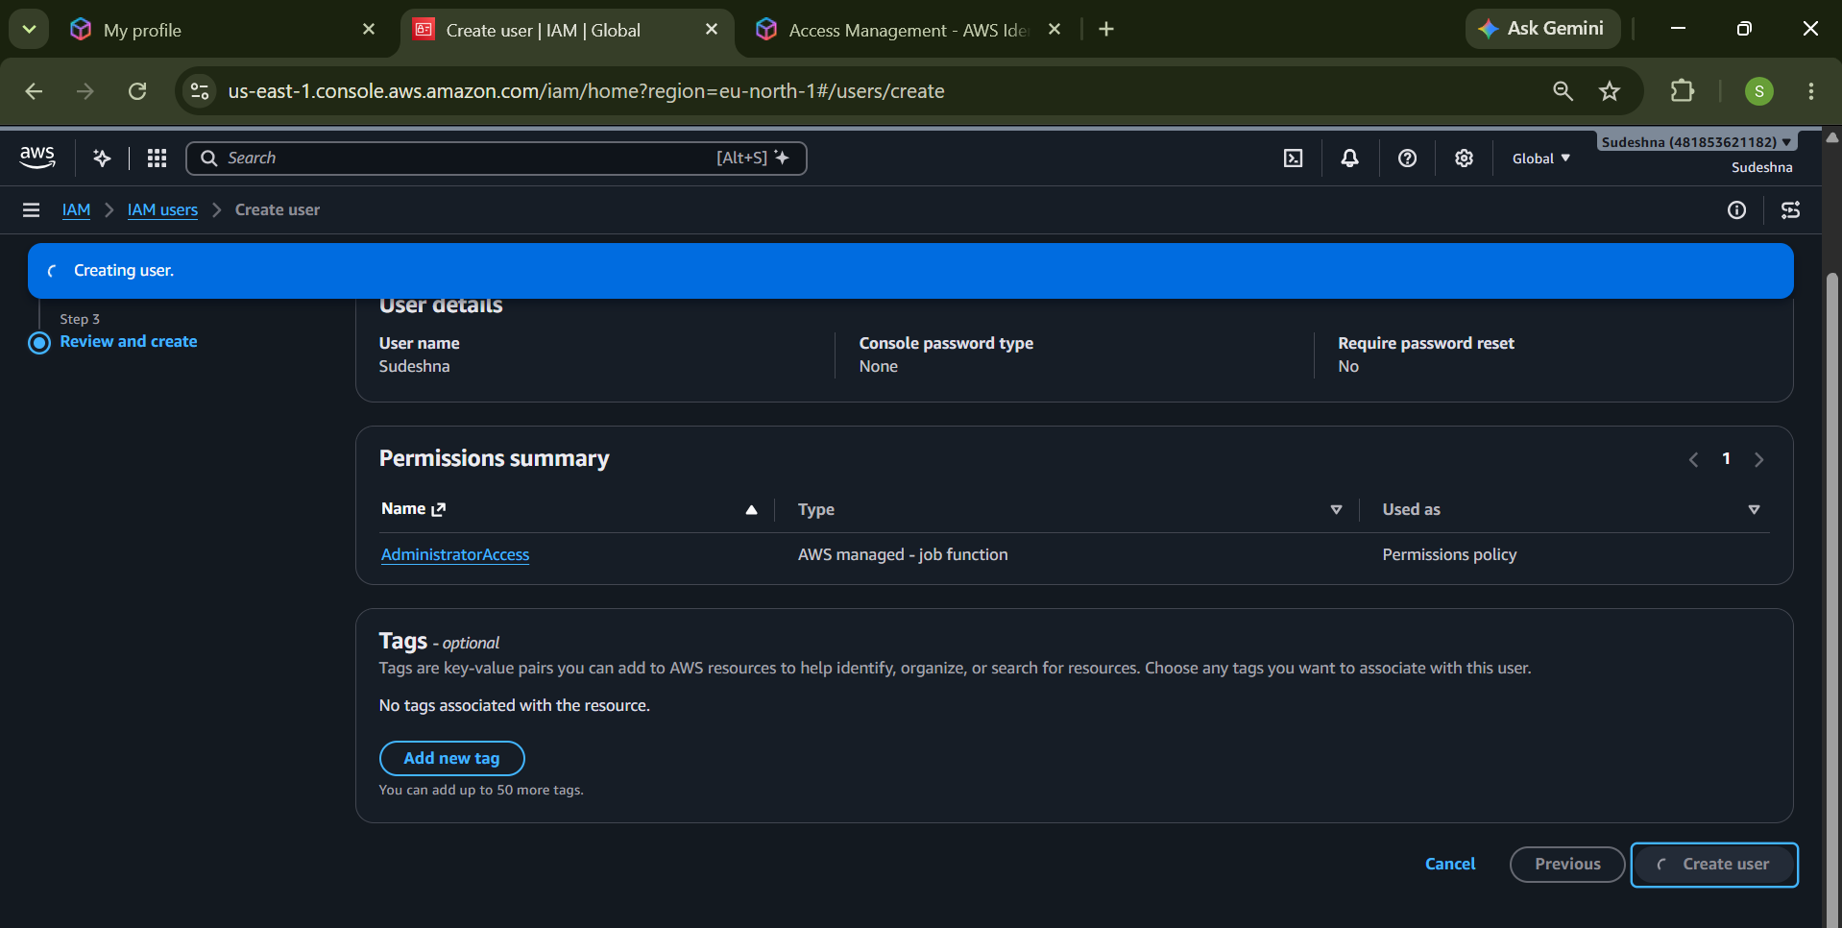
Description: This screenshot displays the IAM user creation process after submitting the configuration.

8. IAM User Created Successfully
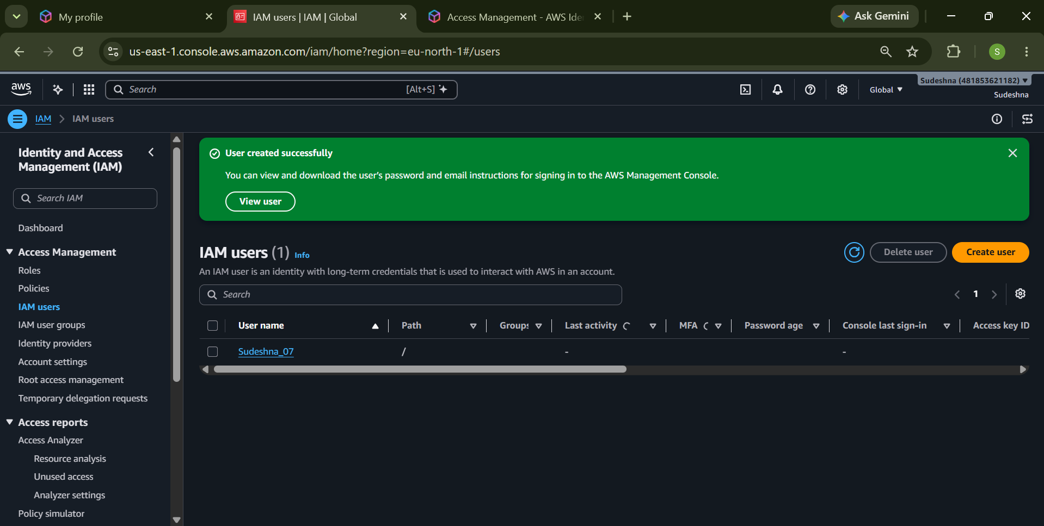
Description: This screenshot shows the IAM Users dashboard with the newly created user displayed in the users list.

9. Access Key Creation
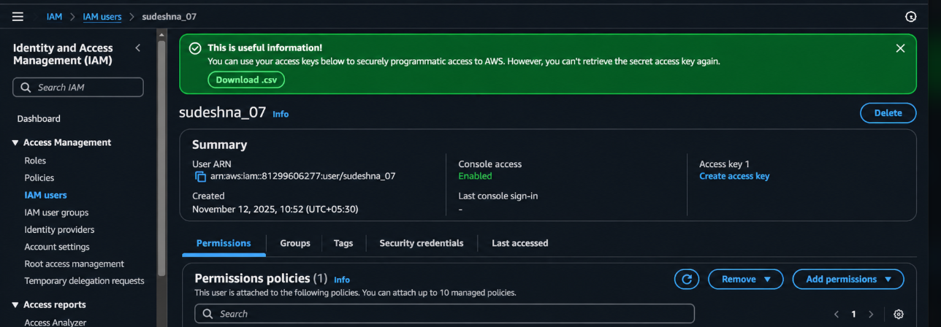
Description: This screenshot displays the access key creation confirmation dialog, which provides information about the generated credentials.

9.1 Navigate to the Security credentials section.
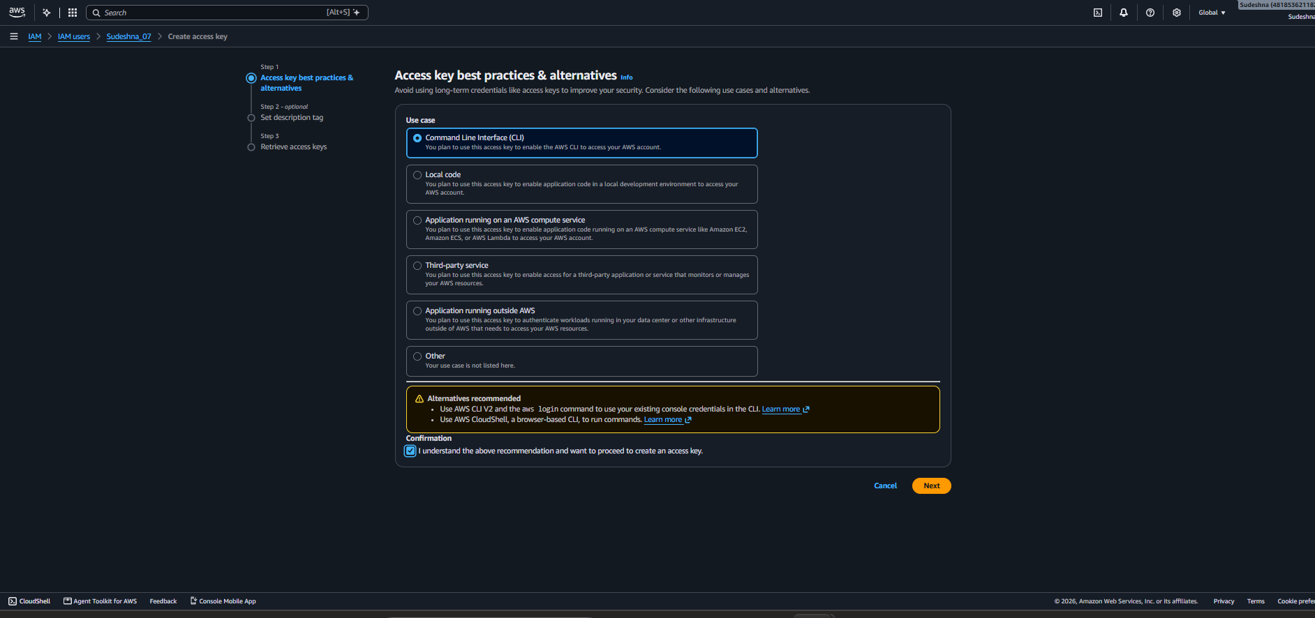
Description: This screenshot displays the access key creation confirmation dialog, which provides information about the generated credentials.

9.2 Set description tag
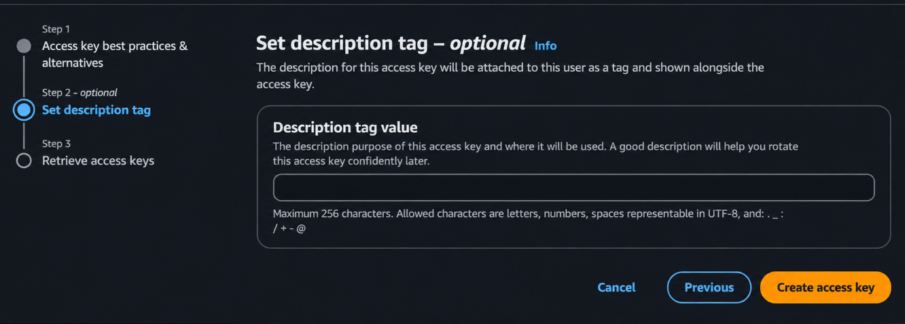
Description: This screenshot displays the set description tags to create access key.

9.3 Retrieve access Keys
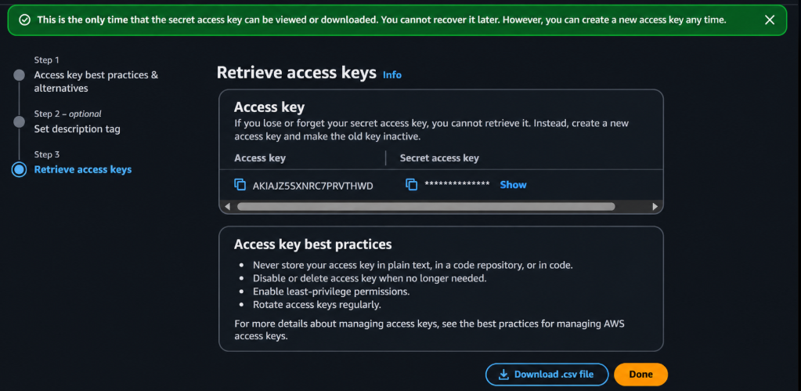
Description: This screenshot displays the access key creation confirmation dialog, which provides information about the generated credentials.

10. IAM User Sign-In Page
Description: This screenshot shows the AWS IAM user sign-in page where the account ID, username, and password are entered.
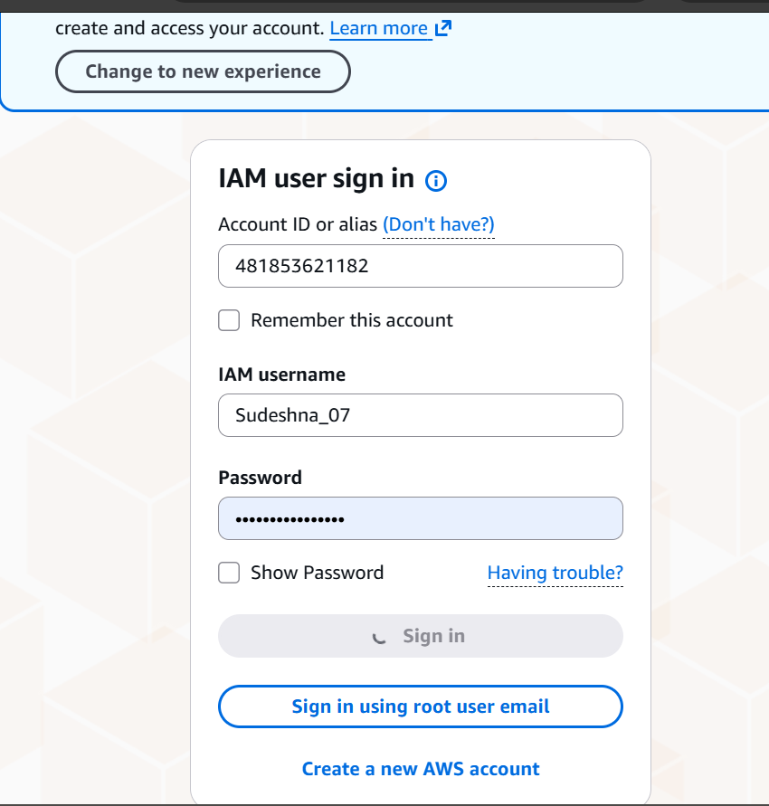

11. Billing Alert Configuration
Description: This screenshot shows the AWS Billing Preferences page where billing notifications and Free Tier usage alerts can be enabled.
11.1Open the Billing and Cost Management dashboard.
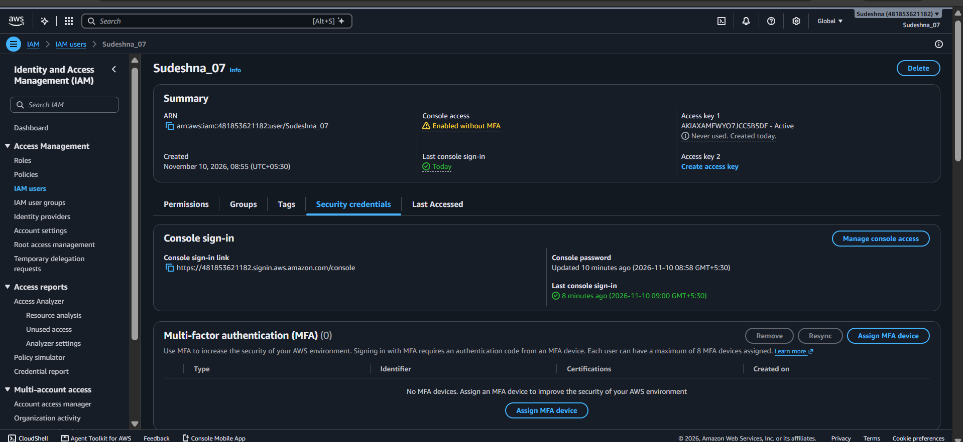

11.2 Budget Alert Configuration – Budget Type and Budget Details Configuration
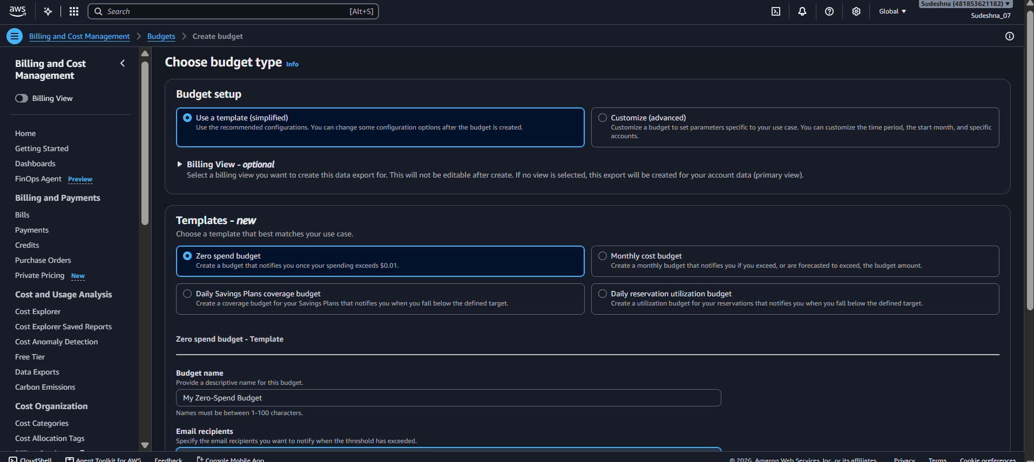
Description: This screenshot shows the budget creation page where the budget type and template are selected and budget configuration page where the budget name and alert threshold details are entered.

11.3 Budget Created Successfully
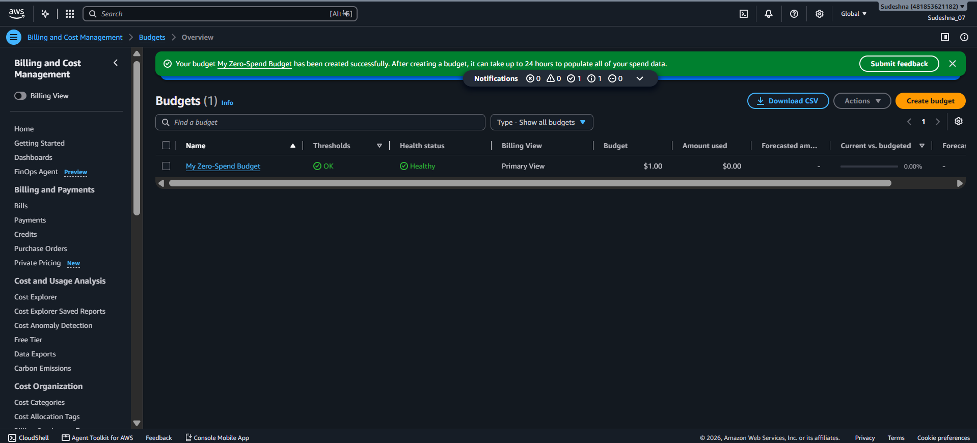
Description: This screenshot shows the AWS Budgets dashboard displaying the newly created budget.

OUTPUTS:
Creating a IAM user
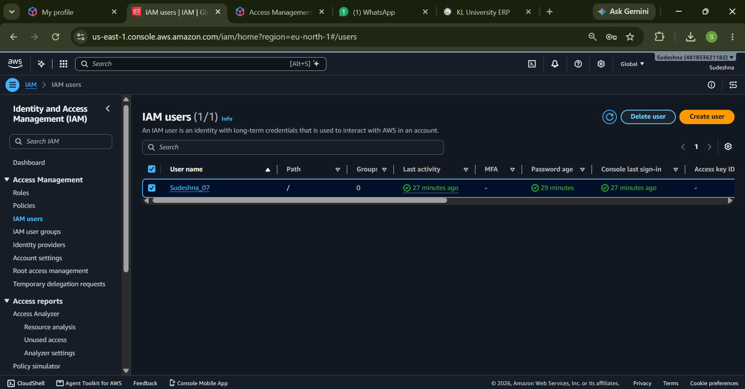
Creating a Budget

DELETING AN ACCOUNT



